**Widget URL Generator**

1. Environment Setup
2. Install the latest Node.JS from <https://nodejs.org/en/download/>
3. Install the latest Express.JS follow the instruction from <https://expressjs.com/en/starter/installing.html>
4. Start the WidgetURL Generator
5. Open a new terminal and go to the application path.
6. Type “node server.js” to start the app  
   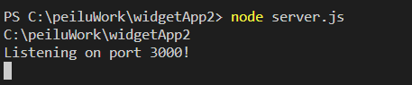
7. Open a browser and go to <http://localhost:3000/>
8. The application homepage will show in the browser.  
   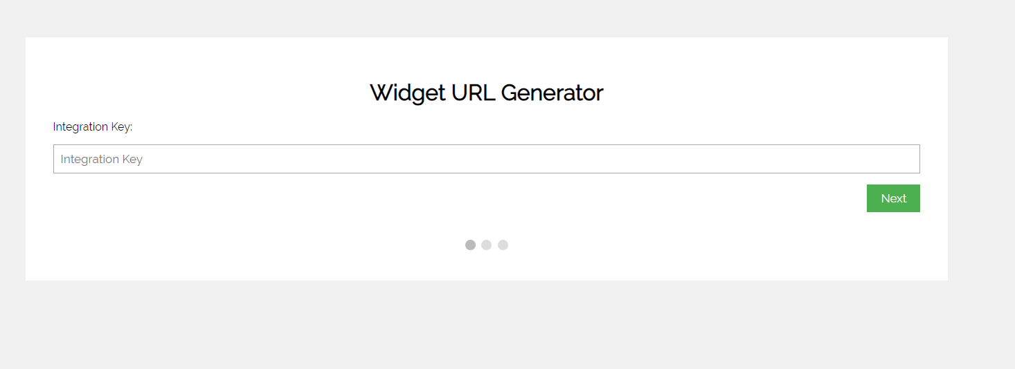
9. Widget URL Generator User Guide
10. Enter the integration key and click “Next”
11. Select a widget from the list.
12. Fill out the form fields that you want them to appear in the Widget URL, and then click Submit
13. A new tab with the generated URL will be opened.